KOZA KLAMF

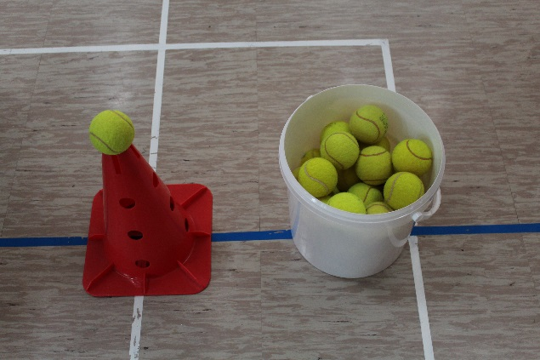
YOU NEED:
- A base (table, chair…)
- A goat (bottle, ball, rock, can…)
- Rocks or balls (something to throw that isn't bouncy. Tennis balls not recommended)

Before you start, you choose the herder. You mark the Herder's territory and decide from where you will throw. You put the Goat on the base and you may begin the game.

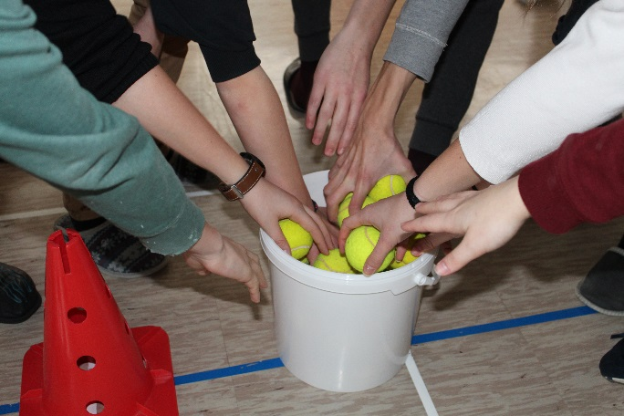
RULES:
Everyone gets only one ball/rock. Players try to knock the Goat off its base. If they throw and miss, they can enter the Herder's territory and collect it without the Herder trying to catch them. However, if they throw and hit the goat, the Herder will put the goat back and try to catch the player that knocked it down while he/she tries to collect his/her ball/rock. The Herder can catch the player only while he/she is in the Herder's territory, so that player must run. The only way to be safe is to touch your rock that is on the ground. If the Herder catches him/her, they switch roles. If the Herder doesn't catch the player, the players start throwing again.
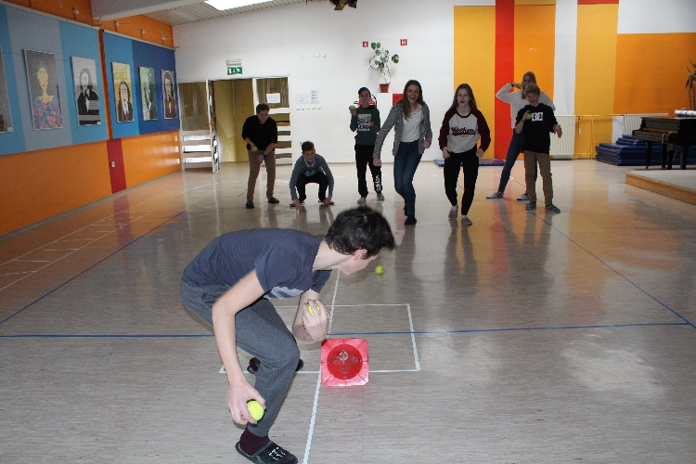
RULES FOR THE HERDER:
Your job is to stand by the Goat while others try to knock it down. You can't block their hits. If they don't hit the Goat, you leave them alone while they collect their ball/rock. Whoever manages to knock it down, you have to put the goat back on its base. Once that is done, you have to catch the one that hit it. You can't catch him/her if they are touching their ball/rock on the ground. Once they pick it up, you can continue the chase. If you catch him/her, you switch roles.

